FMHS Varsity Blue Wave Volleyball Tournament
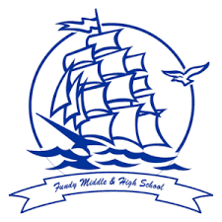
Date: Saturday, May 2
Location: Fundy Middle and High School, St. George
Scorekeepers will be provided
Please bring your own balls
Format: 4 girls teams in Division A / 4 boys teams in Divion B
Round robin play (Best 2 of 3) / Championship Game 1st vs 2nd (Best 2 of 3)

 | Division A (Girls) | Division B (boys)
Game 1 @ 9:00 | 1 vs 4 | 1 vs 4
Game 2 @ 10:15 | 2 vs 3 | 2 vs 3
Game 3 @ 11:30 | 1 vs 3 | 1 vs 3
Game 4 @ 12:45 | 2 vs 4 | 2 vs 4
Game 5 @ 2:00 | 1 vs 2 | 1 vs 2
Game 6 @ 3:15 | 3 vs 4 | 3 vs 4
Championship Games @ 5:00 | 1st vs 2nd | 1st vs 2nd

Division A Teams (Girls) Division B Teams (Boys)
1 – FMHS 1 – St. Stephen
2 – Salisbury 2 - Harvey
3 – Bathurst 3 – Salisbury
4 – Harvey 4 – FMHS

