CFAS Tournament

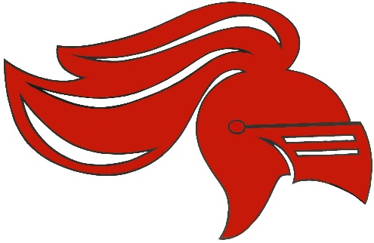

Schedule

Pool A | Pool B
- Chipman | 5. Minto
- Cambridge-Narrows | 6. Bellisle
- Stanley | 7. Harvey
- OHS JV ex | 8. Central New Brunswick Academy
1 v 2 | 9:00 | 5 v 6
3 v 4 | 10:00 | 7 v 8
1 v 3 | 11:00 | 5 v 7
2 v 4 | 12:00 | 6 v 8
1 v 4 | 1:15 | 5 v 8
2 v 3 | 2:15 | 6 v 7
1A v 2B | 3:15 | 1B v 2A
Final | 4:30

* There will be a cash only canteen on site

