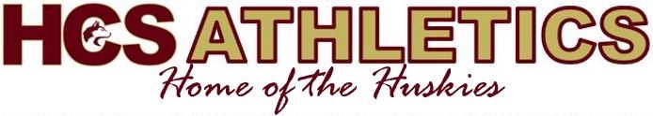

John Glass Invitational Tournament
December 16th and 17th, 2022

Saturday, December 16 Sunday, December 17
12 :00pm | HHS | vs | HCS |  | 10 :00am | GMCS | vs | CICS
1 :45pm | SHS | vs | CICS |  | 11 :45am | HHS | vs | SHS
3 :30pm | GMCS | vs | HHS |  | 1 :30am | HCS | vs | GMCS
5 :15pm | HCS | vs | CICS |  | 3 :15am | CICS | vs | HHS
7 :00pm | SHS | vs | GMCS |  | 5 :00pm | SHS | vs | HCS

Team listed second will wear dark
Warm up will be 15 minutes and start as soon as preceding game has finished.
Five-minute half, One minute between quarters
Coaches will select player of the game from their own team
Admission - $5 for day pass, $8 for a tournament pass
Tournament fee is $225. Please make cheques payable to Hartland Community School

Questions or comments please contact:
Kerri Trecartin – Head Coach – kerri.trecartin@nbed.nb.ca
Jamie Allison – Athletic Director – james.allison@nbed.nb.ca

